# George’s Code: Implement “Shuffle Towns” Functionality

George wants to implement **new functionality** to **shuffle towns** in random order:

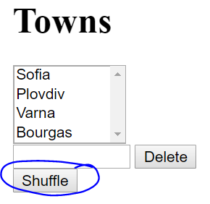 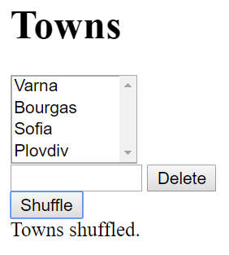

He **clones** the project repository, makes a sequence of **changes** in the source code files, **commits** locally in his repository, then **pushes** the committed changes to GitHub.

## Clone the “Towns” Repository

George starts by **cloning** the project repository:

|  |
| --- |
| git clone https://github.com/SoftUni/towns |

## New Town Textbox + Button

In towns.html, he adds a textbox + button for creating a new town:

|  |
| --- |
| <div>  <button id="btnShuffle">Shuffle</button>  </div> |

## Shuffle Towns JavaScript Code

In towns.js, he adds a new function to shuffle the towns:

|  |
| --- |
| function shuffleTowns() {  let towns = $('#towns option').toArray();  $('#towns').empty();  shuffleArray(towns);  $('#towns').append(towns);  $('#result').text("Towns shuffled.");  function shuffleArray(array) {  for (var i = array.length - 1; i > 0; i--) {  var j = Math.floor(Math.random() * (i + 1));  var oldElement = array[i];  array[i] = array[j];  array[j] = oldElement;  }  }  } |

Also, he adds a code to **attach an event handler** to invoke the new function when the **[Add]** button is pressed. In the start of the JS code, he adds the code marked in **bold** below:

|  |
| --- |
| $(document).ready(function() {  …  $('#btnShuffle).click(shuffleTowns);  }); |

## Test the Project Functionality

George now **tests the project functionality** to see whether the shuffle button works correctly, as well as whether the entire project works as expected:

 

## Commit All Changes in the Local Repo

George **adds** and **commits** in Git all local changes:

|  |
| --- |
| git commit -a -m "Implemented functionality to shuffle the existing towns" |

## Push the Local Commits to GitHub

George pushes all his changes to Git:

|  |
| --- |
| git push |

## Resolve Any Conflicts

In case of **conflict** George **pulls**, **merges**, then **pushes** again:

|  |
| --- |
| git pull |

George edits all files and fixes the code in order to merge all concurrent changes correctly.

Then, George adds and commits in Git the merged files:

|  |
| --- |
| git commit -a -m "Implemented functionality to shuffle the existing towns + merged the conflicting files" |

Finally, George pushes all his changes again to Git:

|  |
| --- |
| git push |